95學年度大學甄選入學綜合評量筆試
考生注意：
- 核對試卷與考桌上之座位號碼是否相符。
- 請於各題框線內作答，試卷背面可當計算用。
- 試卷上座位號碼不得自行撕毀，亦不得擅自拆開彌封，違者該科試卷不予計分。
- 試卷限以黑色或藍色筆書寫。

總分：

- 圖一中方塊之質量為m，施力P 方向與斜坡平行，靜摩擦系數為μ_{s} ，動摩擦系數為μ_{k}，設方塊正以 4m/s 之速率往上坡方向滑動。(1) 試繪出作用在方塊上之摩擦力，並計算此力之大小 (2分) ; (2) 以上資訊是否足夠讓你算出 P 的大小，如足夠，請算出P；如不足，請說明你尚需那些資訊 (2分)。

θ
p
圖一

答案 (1)
答案 (2)

- 如下圖二 a 與 b 所示，車子為前輪驅動，其重量為w，設車重平均分攤到兩個輪子上；圖二a中車子停靠在斜坡上，圖二b 車子正往上坡方向行駛，試在圖中繪出作用在兩個輪子上的摩擦力 F₁ 與 F₂，並說明 F₁ 與 F₂ 之關係。(6分)
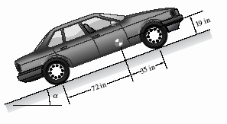
F₁與 F₂之關係:
F₁與 F₂之關係:
圖二a

θ
圖二b

θ

- 請仔細閱讀下面有關牛頓生平的文章，並回答相關問題:
Newton was born in sixteen-forty-two in Woolsthorpe, England. During his lifetime, he made discoveries in astronomy, mathematics, optics, and physics. They helped change the direction of scientific discovery for centuries.
Newton received his education at Trinity College in Cambridge, England. He invented the theory of integral calculus in the sixteen-sixties. Calculus is the area of mathematics that deals with changing amounts, or quantities. A German mathematician, Gottfried Wilhelm von Leibniz, developed differential calculus independently.
Newton discovered how the universe is held together. He called this theory the “Law of Universal Gravitation.” He explained his ideas in a book commonly called “Principia.” It is considered by experts to be one of the greatest scientific books ever written. It includes Newton’s three laws of motion. His first law of motion states that an object in motion will continue moving unless it is affected by a foreign, or outside, force. His second law says the speed of an object depends on two things -- the force acting on the object and the object’s mass. His third law states that, for every action, there is an equal and opposite reaction. Newton showed that white light was made up of colors mixed together. He discovered this through a series of experiments with a prism of cut glass. He used his discoveries to build a reflecting telescope. It used a flat surface to show images of objects in the sky.
Isaac Newton died in seventeen twenty-seven. He was buried at Westminster Abbey in London. Today, he is considered one of the greatest scientists who ever lived. His laws and theories influenced religion and culture for years after his death.
(文章摘錄自美國之音某段廣播)

- 文中共提到牛頓所發現的定律共有幾條? (2分)
答案：

- 文中共提到那幾個科學家? (2分)
答案：

- 文中是否有提到牛頓與其他人共同合作研究某一門學問，如有，是那一門學問? (2分)
答案：

- 文中提到牛頓在那幾門科學有重要貢獻。(2分)
答案：

- 文中提到牛頓在那裏受教育? (2分)
答案：
- 下圖中不倒翁娃娃是由圓盤和一個扇形盤組成，不倒翁被放置在一個平板上。
  - (5分)如果圓盤質量為m，它的質心位置為Y_{m}；扇形盤的質量為P，它的質心位置為Y_{P}；請推導出整個不倒翁的質心位置Y_{T}。

答案：
  - (5分)如果圓盤直徑為d，扇形盤半徑為R，扇形角度為θ，圓盤和扇形盤厚度都為b。圓盤和扇形盤都是使用同一種材料製成，材料密度為ρ。請以座標(x, y)方式定出不倒翁的質心位置Y_{T}。(座標(0,0)為穩定位置接觸線的中心點。)

答案：

  - (5分)請根據上面第(2)小題所得結果，在不考慮動能的狀態下，建立出不倒翁的最大穩定傾測角度Ψ_{max}（最大不會傾倒的角度）與質心位置Y_{T}和扇形盤半徑R之間數學關係。（提示：不倒翁支撐點會隨著傾側角度有所變化。）
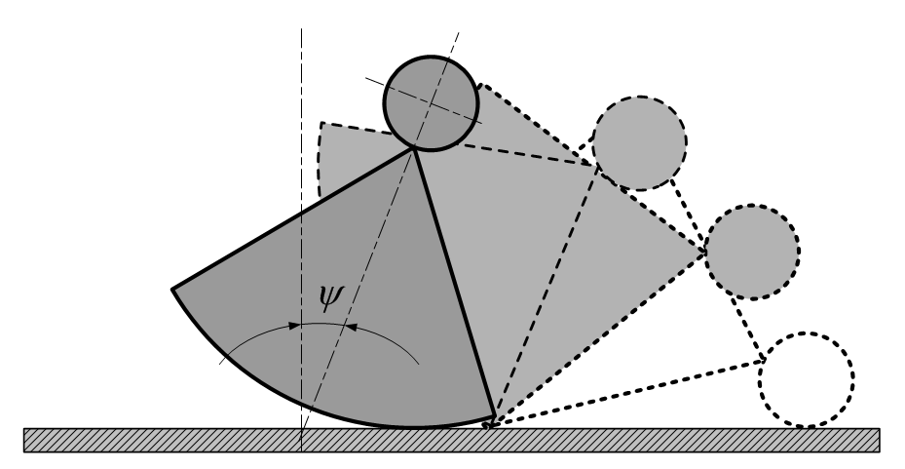
答案：

- (5分)一個液體容器如下所示，A桶容積＝B桶容積＝管路的總容積，管路由相同長度的半圓管和直管組成，半圓管C長度=半圓管D長度＝直管E長度，假設通氣管的容積忽略不計。
開始進水前，所有容器都沒有水。水慢慢地注入A桶中，總共要加入3個A桶容積的水，請繪出B桶儲水量和A桶進水量之關係圖。(請在圖(2)的曲線座標圖上直接繪出一條連續曲線，部分度量必須自行估計)
(1)裝置圖
答案：(2)曲線座標圖

- （1）(5分)試述熱汽球的基本飛行原理。
（2）(5分)由地面充填一氫氣球（假設不會破），若將它瞬間送至月球背太陽（陰暗）面，則當抵達後此原本飽滿的汽球其形狀可能如何轉變？
（3）(10分)有兩太空人在地球外一靜止太空船艙外工作，利用背負式推進器，維持兩太空人靜止狀態。此時兩人同時關閉推進系統，(a) 艙內的人看他們如何移動？ (b) 在甲眼中的乙又將如何移動？ (c) 若甲知道自己位移大小，以及與乙之間的距離，可否估算出自己和太空船離地球約多遠？(右為提示圖）。
答案：
- (10分) It is well known that the speed of light is C km/hr, and the speed of sound is B km/hr. A private investigator is driving a car at a constant speed of A km/hr along a straight freeway towards a freeway gas station. When the distance between the investigator and gas station is X km, the gas station explodes. (1) How much more distance does the investigator drive when he sees the light of explosion? (2) How much more distance does the investigator drive when he hears after he saw the explosion? (3) How much time does the investigator take to arrive at the gas station after the explosion? (4) If C>>A, C>>B, and B>>A, what are those approximate distance in (2)?
答案：

- (10分) 蜘蛛人用蜘蛛絲分掛在相距20公尺的大樓牆壁A, B兩點, 試圖停止一輛煞車失靈急駛中的高架軌道電車, 蜘蛛絲的彈力和伸長量的關係如圖左, 電車速度大小與位移的關係如圖右, 請估算電車和乘客總質量為多少? 請寫出你的估算依據那些假設條件?
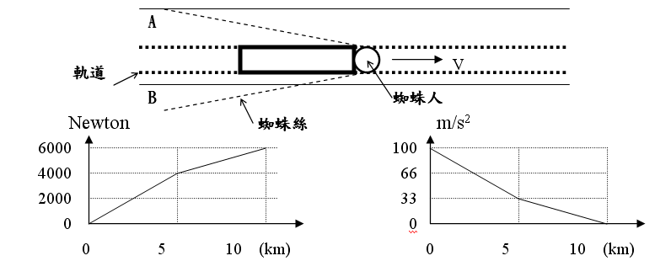
答案：

- (10分) Determine and prove the following sequences converge or diverge?
(1)${\left\{\frac{1^{\text{49}}+2^{\text{49}}+3^{\text{49}}+⋯+n^{\text{49}}}{n^{\text{50}}}\right\}}_{n=1}^{∞}$ (2) ${\left\{(1+\frac{2}{n})^{n}\right\}}_{n=1}^{∞}$ (3) ${\left\{\frac{e^{n}}{n}\right\}}_{n=1}^{∞}$(4) ${\left\{\frac{\text{sin} n}{n}\right\}}_{n=1}^{∞}$ (5) ${\left\{\frac{\text{ln} n}{n}\right\}}_{n=1}^{∞}$
答案：

- (10分)下面有一段關於半導體製程的描述, 請閱讀後回答下列問題：
The world’s most sophisticated cameras—the lithography machines that project a circuit image onto a photochemical “resist” covering the silicon wafer, the disk that is later cut up into individual chips. A developing chemical removes, say, the exposed area, and then an etching chemical transfers the pattern into the wafer.
The most common method of making circuits smaller is to reduce the wavelength of light with a machine that traces progressively tinier circuit features on a wafer. Lithography toolmakers had bumped up against numerous obstacles in making a machine that radiates wavelengths of 157 nanometers. Going from one lithography generation to another requires adoption of new lasers, masks (the stencil-like pattern of circuits through which laser light is projected), lenses that reduce the image size and exposure, and photoresists. For 157 nanometers, equipment companies could not figure out how to fashion lenses from calcium fluoride with few enough defects and optical aberrations to form a clear image on the wafer.
In the summer 2002, Burn Lin, an executive from Taiwan Semiconductor Manufacturing Company, the world’s largest contract chip manufacturer, was scheduled to give a speech on immersion lithography, a hand-me-down from Amici’s ideas. Physicist Giovanni Battista Amici placed a drop of liquid on a specimen in his Florence laboratory, improving the quality of the image seen through his microscope’s eyepiece. Now, 165 years later, the global semiconductor industry is just getting around to adopting Amici’s innovative technique. The decision to baptize chips under a thin liquid stratum will allow the making of circuits with features that measure the breadth of a virus.
Water, which is transparent to 193 nanometer radiation but not to 157 nanometer, can enhance resolution because it enables a lithography machine to be built with a higher numerical aperture, a key factor in its ability to resolve fine detail. Water also improves the depth of focus—the distances from the camera at which the image projected onto the photoresist stays acceptably sharp. Depth of focus remains a particular concern in advanced chipmaking because the slightest unevenness on the wafer surface can spoil the image. The refractive index of water—the ratio of the speed of light in a vacuum to that of its speed in a medium such as water (essentially a measure of water or another medium’s ability to bend light and a critical parameter for figuring numerical apertures)—
(from SCIENTIFIC AMERICAN, July 2005)

答案：(複選,每題可能有一至五個正確的答案)
- “lithography”的主要功用:
  - 切割晶圓, (b)侵蝕化學阻膜, (c)塗化學劑在晶圓上 (d)投影電路圖像在化學阻膜上, (e)製作光罩(mask)

- 下列何者是用較短波長157nm光波去縮小晶片上的電路所遇到的難題:
  - 沒有合適的透鏡, (b)曝光時間不夠 (c)焦距變大 (d)無法清楚成像 (e)穿透力太強

- 水對193nm波長的光波發揮了什麼效果?
(a)光在水中的波長縮短, (b) 產生較大的數字孔徑（numerical aperture）, (c)形成氣泡提高反射率, (d) 提高成像清晰度 (e) 改善聚焦深度

