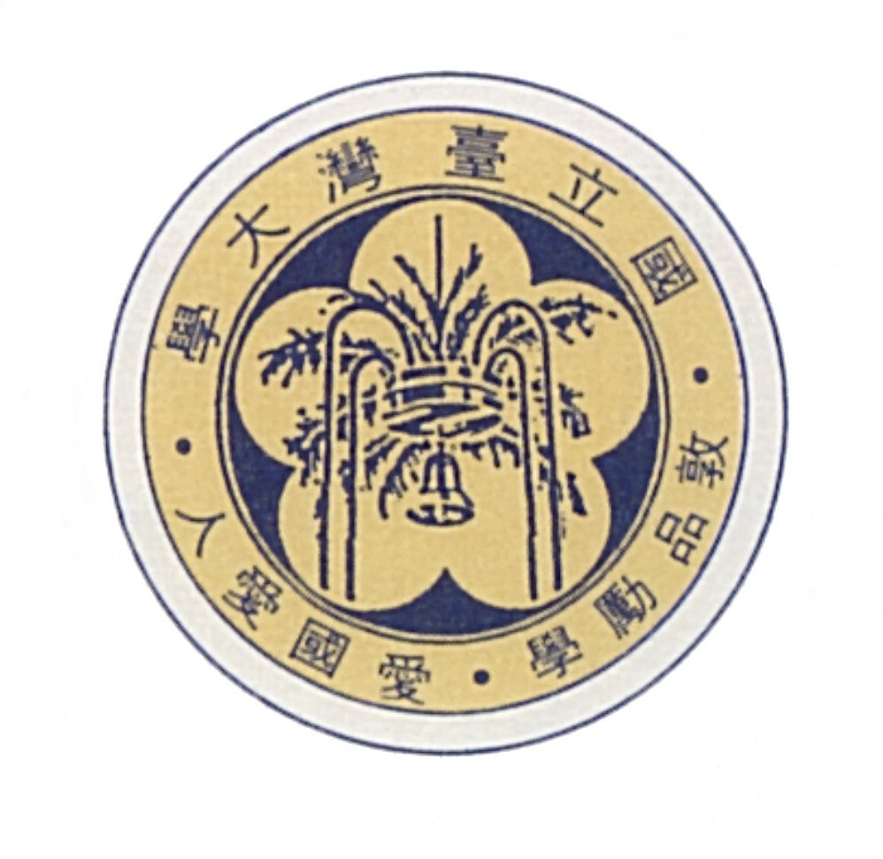
國立台灣大學機械工程學系暨研究所

演 講 公 告

時 間 及 地 點

99年8月18日(星期三) 10:00 ~ 12:00 台大工學院綜合大樓734室

系統控制系列演講

Digital Signal Processing via Sampled-Data Control
-Beyond the Shannon Paradigm
Professor Yutaka Yamamoto, IEEE Fellow
Department of Applied Analysis and Complex Dynamic Systems, Graduate School of Informatics, Kyoto University

Parametric and Symbolic Approaches in Control System Analysis and Design
Professor Hirokazu Anai
IT System Laboratory, Fujitsu Laboratories Ltd / Graduate School of Mathematics, Kyushu University

Plant-Controller Integrated Design by Means of Algebraic Approaches
Professor Masaaki Kanno
Department of Information Engineering, Niigata University

Model-Based Control of Air Intake System in Diesel Engines
Dr. A. Ejiri
Autonomous Systems Laboratory, Fujitsu Laboratories Ltd

Digital Signal Processing via Sampled-Data Control
-Beyond the Shannon Paradigm

There has been remarkable progress in sampled-data control theory in the last decade. The main accomplishment here is that there exists a digital (discrete-time) control law that takes the intersample behavior into account and makes the overall analog (continuous-time) performance optimal, in the sense of H-infinity norm. The same hybrid nature of designing a digital filter for analog signals is also prevalent in digital signal processing. A crucial observation is that the perfectly band-limited hypothesis, widely accepted in the signal processing literature, is often inadequate for many practical situations. In practice, the original analog signals (sounds, images, etc.) are neither fully band-limited nor even close to be band-limited in the current processing standards.
This is the problem of interpolating high-frequency components, which in turn is that of recovering the inter-sample behavior. Sampled-data control theory provides an optimal platform for such problems. This talk provides a new problem formulation, design procedure, and various applications in sound processing/compression and image processing.

Speaker
Professor Yutaka Yamamoto, IEEE Fellow
Department of Applied Analysis and Complex Dynamic Systems,
Graduate School of Informatics, Kyoto University

Professor Yutaka Yamamoto was born in 1950. He received his B.A. and M.S. degrees in 1972 and 1976, respectively, from Kyoto University, and M.S. and the Ph.D. degrees in mathematics from the University of Tokyo in 1976 and 1978, respectively. His Ph. D. advisor is Professor R. E. Kalman. Since 1978, he has been with Kyoto University, and became a professor in 1997. His research interests are control theory and engineering. He is also an IEEE Fellow.
Parametric and Symbolic Approaches
in Control System Analysis and Design

Nowadays computer algebra is becoming increasingly common as an effective tool in many fields i.e., science, engineering and education. In control community symbolic approach has been used in a wide variety of contexts. In this talk we discuss some crucial efficacies of symbolic and algebraic methods in control system design. One of the key features of symbolic approach is “parametric” treatment of control design problems. It enables us to develop a parametric approach to robust control in a systematic way. This talk provides a broad overview of such a symbolic approach to parametric robust control design with some control examples. Our toolbox for parametric robust control on Maple/MapleSim (or MATLAB) will be used for demonstrating such control applications. The toolbox is based on symbolic methods such as quantifier elimination and some elimination methods.

Speaker
Professor Hirokazu Anai
IT System Laboratory, Fujitsu Laboratories Ltd / Graduate School of Mathematics, Kyushu University

Hirokazu Anai was born in 1966. He graduated in 1989 from the Department of Physics in Kagoshima University, Japan and received his M.S. degree in 1991, and the Ph.D. degree in information physics and computing from the University of Tokyo in 2008. Since 1991 he has been with Fujitsu Laboratories Ltd and become a senior researcher in 2007. He was a guest researcher at Fakultät für Informatik und Mathematik of the University of Passau, Germany in 1999-2000. He was a reader of CREST project, ``Construction of a platform for robust optimization based on symbolic-numeric hybrid computation" of Japan Science and Technology Agency in 2003-2009. Moreover, since 2008 he has been a Professor of Graduate School of Mathematics and Mathematical Research Center for Industrial Technology (MRIT) of Kyusyu University. Current research concerns effective quantifier elimination, symbolic-numeric methods for solving real algebraic constraints and their practical applications.
Plant-Controller Integrated Design
by Means of Algebraic Approaches

In control system design, in addition to having good controller synthesis methodologies, it is also important to design a plant that is easy to control so that a good control performance can be achieved. Various approaches have been proposed for plant-controller integrated design where a plant and a controller are simultaneously designed. Most of approaches proposed so far are based on numerical methods. In this talk, an approach based on algebraic methods is presented that exploits the Sum of Roots for polynomial spectral factorization. It is discussed that the approach allows design of a controller for a plant with real parameters and thereby can be extended to the integrated design.

Speaker
Professor Masaaki Kanno
Department of Information Engineering, Niigata University

Masaaki Kanno received the Bachelor's degree in mechanical engineering and the Master's degree in information engineering from the University of Tokyo in 1991 and 1993, respectively, the MPhil degree in control engineering from the University of Sussex, Brighton, UK, in 2000, and the PhD degree in control engineering from the University of Cambridge, Cambridge, UK, in 2004. He joined Isuzu Motors Ltd in 1993 and worked as a design engineer of diesel engines for passenger cars/light duty trucks. He also worked as a Research Associate at the University of Cambridge from 2003 to 2005, and as a Research Fellow of CREST, Japan Science and Technology Agency from 2005 to 2009. Since 2009, he has been an Associate Professor of the Department of Information Engineering, Niigata University. His research interests include robust control, application of algebraic methods to analysis/synthesis of control systems, guaranteed accuracy computation in control.
Model-Based Control of Air Intake System in Diesel Engines

For the purpose of contributing to global environment protection, several research studies have been conducted involving clean-burning diesel engines. In recent diesel engines with Exhaust Gas Recirculation (EGR) systems and a Variable Nozzle Turbocharger (VNT), mutual interference between EGR and VNT has been noted. Hence, designing and adjusting controller of the conventional PID controller is particularly difficult at the transient state in which the engine speed and fuel injection rate change. We propose a model-based control system with the MIMO/SISO switchable Controller, the Dynamic Feed-forward and Disturbance Observer using an engine transient model. Using this method, we achieved precise reference tracking and reduced emissions.

Speaker
Dr. A. Ejiri
Autonomous Systems Laboratory, Fujitsu Laboratories Ltd.

Arata Ejiri graduated in 1987 from the Department of Mechanical Engineering in Tokyo Institute of Technology, Japan and received his M.S. degree from Tokyo Institute of Technology in 1989. Since 1989 he has been with Fujitsu Laboratories Ltd. His current research interests are in the simulation, modeling and control of air intake system in diesel engines.

