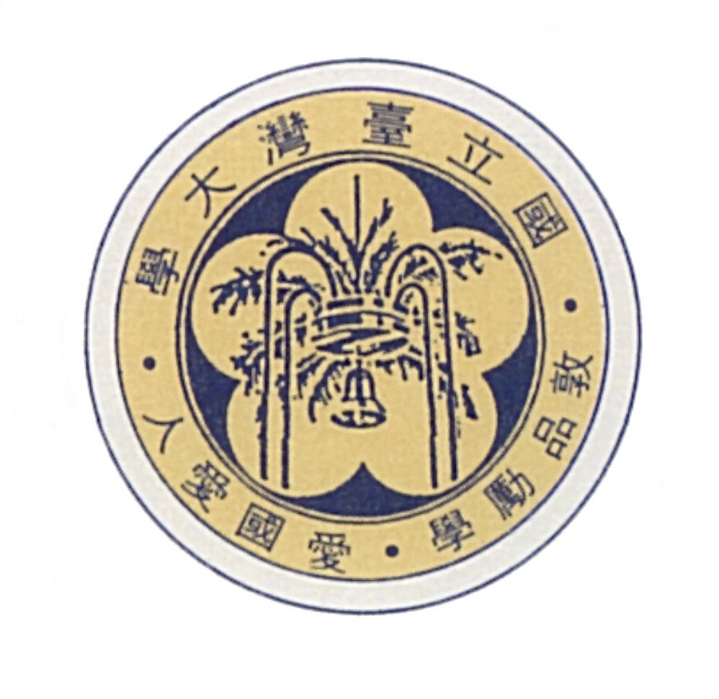
國立台灣大學機械工程系暨研究所

Department of Mechanical Engineering, National Taiwan University,
1, Sec. 4, Roosevelt Rd., Taipei, Taiwan, ROC
Tel: +886-2-2362-0032, Fax: +886-2-2364-1186
2009傑出校友演講公告

主講人 何志明 教授
Director
Center for Cell Control
Henry Samueli School of Engineering and Applied Science
University of California, Los Angeles

講 題 Career Development – A Case Study
時 間 2009年10月19日（星期一）下午02：20 - 05：20
地 點 工學院綜合大樓2F國際會議廳(203)
主持人 系主任 張所鋐 教授
演講摘要
After graduating from the college, young professionals start to develop their careers. The mix of excitements and challenges often makes them feel uncertain to move forward. In next several decades, the technology progresses will accelerate and the changes of the entire society will become even faster. How will these highly trained young men/women to meet these challenges and to adapt to an unknown future? The speaker will share his lifelong experience with the graduate students of his alma matter.
※歡迎各位老師與同學踴躍參與

